CS 4320/5314

HW1: Search Exercises

DUE: Sat, Feb 23 at 11:59 PM

1. (Text 3.6) Give a complete problem formulation for each of the following. Choose a formulation that is precise enough to be implemented.
   1. Using only four colors, you have to color a planar map in such a way that no two adjacent regions have the same color.
   2. A 3-foot-tall monkey is in a room where some bananas are suspended from the 8-foot ceiling. He would like to get the bananas. The room contains two stackable, moveable, climbable 3-foot-high crates.
   3. You have a program that outputs the message “illegal program record” when fed a certain file of input records. You know that the processing of each record is independent of the other records. You want to discover what record is illegal.
   4. You have three jugs, measuring 12 gallons, 8 gallons, and 3 gallons, and a water faucet. You can fill the jugs up or empty them out from one to another or onto the ground. You need to measure out exactly one gallon.

2) (Text 3.14) Which of the following are true and which are false? Explain your answers.

1. Depth-first search always expands at least as many nodes as A\* search with an admissible heuristic.
2. h(n) = 0 is an admissible heuristic for the 8-puzzle.
3. A\* is of no use in robotics because percepts, states, and actions are continuous.
4. Breadth-first search is complete even if zero step costs are allowed.
5. Assume that a rook can move on a chessboard any number of squares in a straight line, vertically or horizontally, but cannot jump over other pieces. Manhattan distance is an admissible heuristic for the problem of moving the rook from square A to square B in the smallest number of moves.

3) Consider the search space below, where S is the start node and G1 and G2 satisfy the goal test. Arcs are labeled with the cost of traversing them and the estimated cost to a goal is reported inside nodes (so lower scores are better).

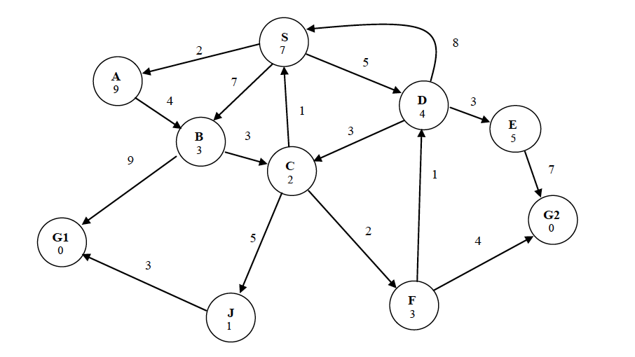

For each of the following search strategies, indicate which goal state is reached (if any) and list, in order, all the states removed from the FRINGE. When all else is equal, nodes should be removed from FRINGE in alphabetical order.

Best-first search

Iterative Deepening

A\* Search